Experiment 3
3. Execute and display the results for the following commands in Kali Linux Operating
Systems:

Tree
Head
Tail
Aim: To execute and study the tree, head, and tail commands in Kali Linux Operating System and observe their outputs.

Commands
mkdir Experiment3
touch Experiment3/file1.txt
touch Experiment3/file2.txt
touch Experiment3/file3.txt
tree
nano data.txt
head data.txt
tail data.txt
1. Tree command:
tree
- The tree command is used to display files and directories in a hierarchical tree-like structure. In this experiment, the Experiment3 directory contains file1.txt, file2.txt, and file3.txt.
the Experiment3 directory contains:
Experiment3
├── file1.txt
├── file2.txt
└── file3.txt
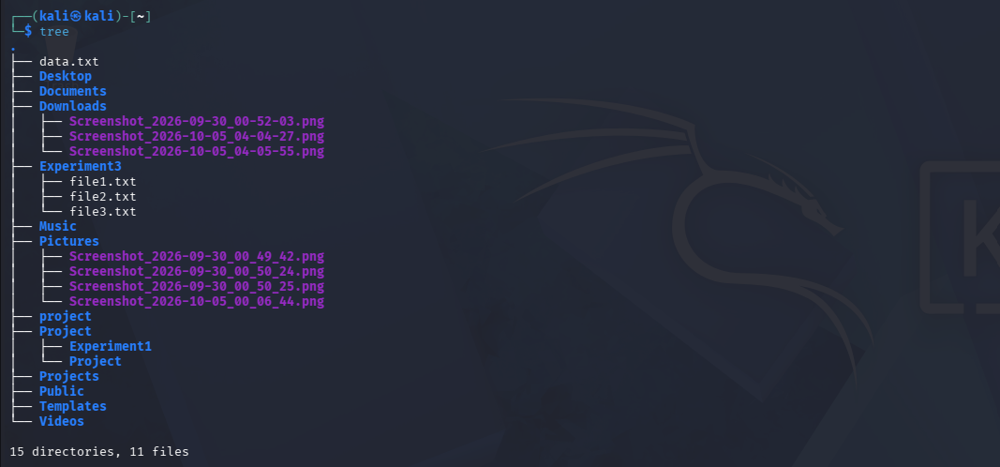

2. Head command:
head data.txt

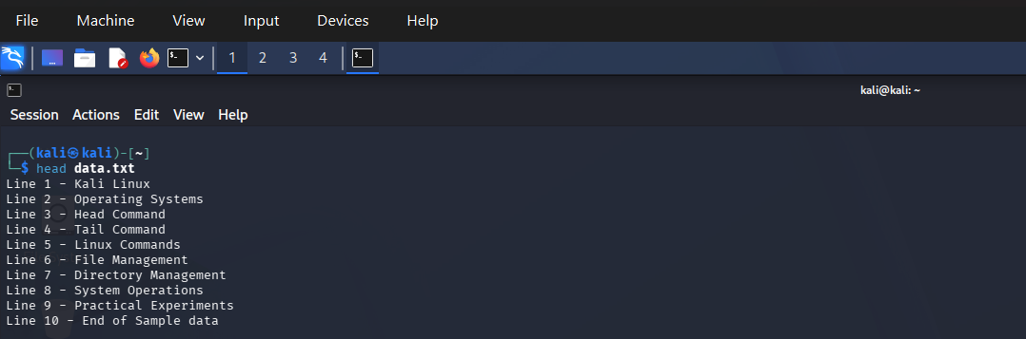
- The head command is used to display the beginning of a text file. By default, it displays the first 10 lines of data.txt.

3. Tail Command:
tail data.txt
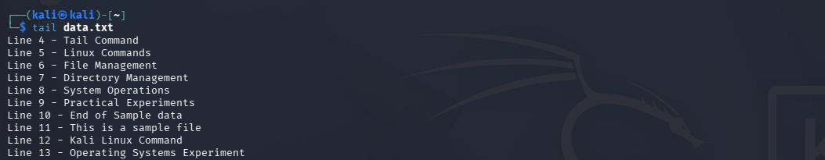
- The tail command is used to display the end of a text file. By default, it displays the last 10 lines of data.txt.
Result: Thus, the tree, head, and tail commands were successfully executed in Kali Linux and their outputs were displayed and verified.

